**Art Dealer Game**

User Manual

Submitted by

Group-6

Durga Vijaya Ramaraju Pamidi

SU25-CPSC-60500-001

**Instructor:** Dr. Fadi Wedyan

Lewis University

Overview:

The **Art Dealer Game** is an interactive and educational card game designed for students in **grades K through 8**. The game simulates the experience of being an art collector or dealer, where players try to sell a set of 4 "art pieces" (represented by playing cards) to a dealer who is only interested in specific kinds of artwork that follow a **secret pattern**.

Each time a player selects 4 cards and submits them, the dealer reveals how many of those cards match their hidden preference. Using logic, observation, and pattern recognition skills, players must deduce the dealer’s buying pattern through trial and error. Once they feel confident, they can **guess the dealer’s pattern**. If they guess correctly, they win the round; if not, they get up to three chances before the game ends and reveals the correct pattern.

This game combines elements of **fun, exploration, and deduction** with **core academic skills** such as:

* **Mathematics** (number recognition, addition, understanding of prime numbers and probabilities)
* **Computational thinking** (pattern identification, logical reasoning)
* **Visual learning** (color, shape, and suit identification)
* **Problem-solving and perseverance**

The game grows with the student by increasing in complexity based on their grade level. Younger students (K–2) begin with simpler color and suit patterns, while older students (grades 3–8) encounter increasingly challenging mathematical and card-based logic patterns, including poker-style combinations like flushes and full houses.

Visually engaging and accompanied by **sound effects and animations**, the game encourages replayability and continued learning in a playful format. It can be used in classrooms, learning labs, or at home, either independently or in small groups. Teachers can also use it as part of a lesson on logic or probability.

Whether you're a young learner discovering patterns for the first time or an older student refining your reasoning skills, the **Art Dealer Game** is a rewarding and educational experience.

**How to download game:**

Github link – <https://github.com/Durga-Vijaya-Ramaraju/SE_Project_Art_dealer_game.git>

For downloading this game please use below github link and download the repository or clone the repository using git clone command shown below

Open terminal and use below command to download the repository

**Command to download:**

$ git clone https://github.com/Durga-Vijaya-Ramaraju/SE_Project_Art_dealer_game.git

**How to start the game:**

Before starting game please ensure that python is installed in your local machine or not. If python not installed use below link to get instructions to install python in your local machine

Instructions for python installation- <https://www.geeksforgeeks.org/python/download-and-install-python-3-latest-version/>

Also be ensure that the python modules tkinter, PIL, pygame, random, threading and time modules installed in your local machine. If they not installed use pip command to install them.

To start game , open downloaded git repository and double click on Art_dealer_game.exe to start the game.

After starting the game the user interface looks like below, which shows deck of cards and gamel level etc.

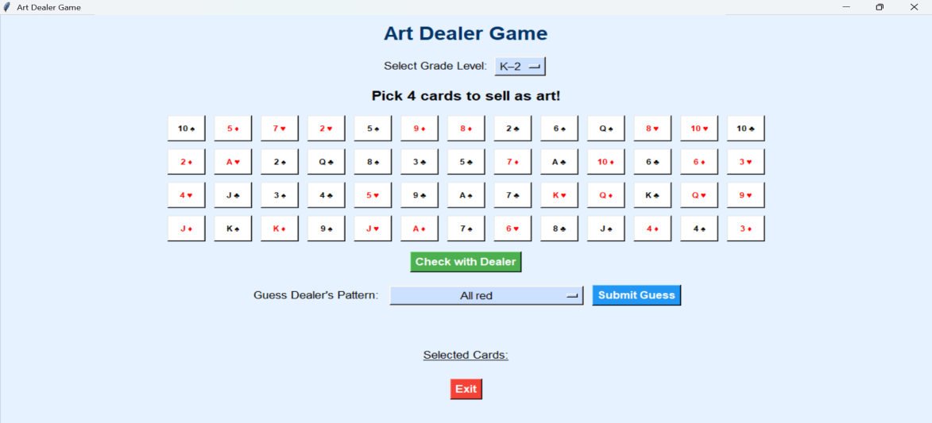

**Level 1: Grades K–2**

This level is designed for **young learners** just beginning to understand patterns and colors. The patterns are simple, visual, and easy to recognize. Students work with ideas like:

* All red cards
* All black cards
* All cards from a specific suit (e.g., hearts or diamonds)
* All queens

**Focus Skills:** Color recognition, suit identification, basic grouping, and visual scanning.

**Level 2: Grades 3–5**

At this level, students are introduced to **basic mathematical reasoning** in addition to the visual patterns. It includes everything from the K–2 level plus new challenges such as:

* Cards that are **single-digit prime numbers**
* A group of cards that **add up to 9**
* A combination of **an ace and a black jack**

**Focus Skills:** Mental math, prime numbers, early combination logic, and number relationships.

**Level 3: Grades 6–8**

This level introduces the most advanced logic and is inspired by classic card game combinations such as poker. Students must recognize and deduce **multi-card relationships** and **strategic patterns**:

* All face cards (J, Q, K)
* Pair, Two pairs, Three of a kind
* Straight (4 cards in numerical sequence)
* Flush (all cards of the same suit)
* Full house (three of one value, two of another)

**Focus Skills:** Probability, set theory, abstract reasoning, and advanced pattern analysis.

These levels not only make the game accessible for a wide range of ages but also help players **progress over time**, providing a rewarding and appropriately challenging experience at each stage of their learning journey.

**How to select different levels:**

After game starts you can able to see select grade level widget in top of screen which is highlighted in below figure, there you can select the level of game you want

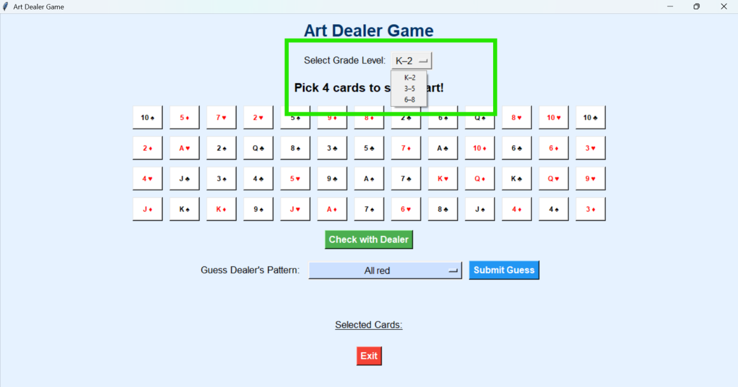

After selecting the level you want then you need to pick 4 deck cards to identify the dealers pattern, for selecting cards you need to just click on the card you want , then the selected cards were shown in below section as selected cards which is shown in below figure

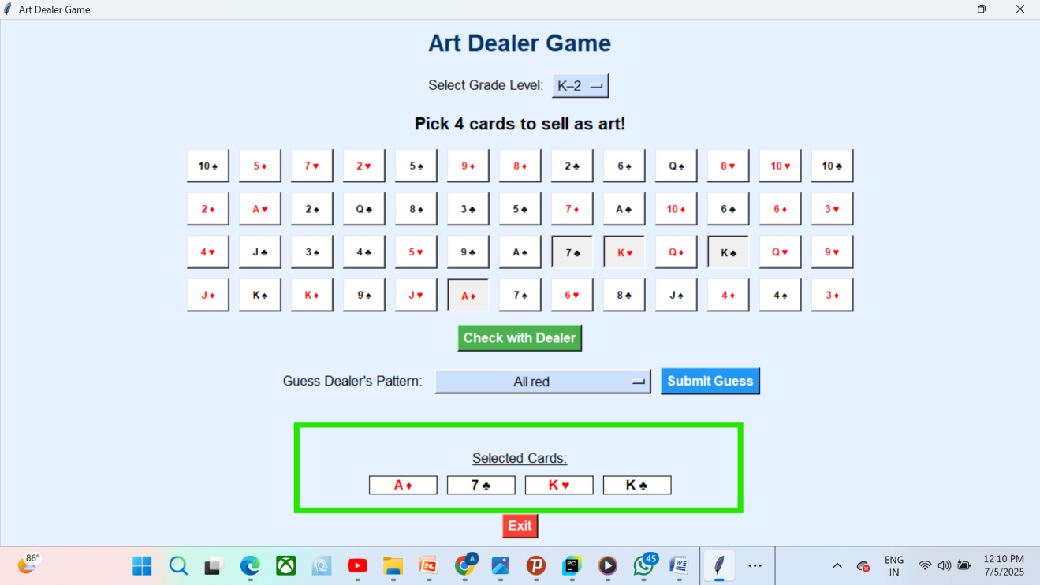

If you select less than 4 cards , and click on check with dealer, a message will popup and said please select 4 cards as shown in below figure

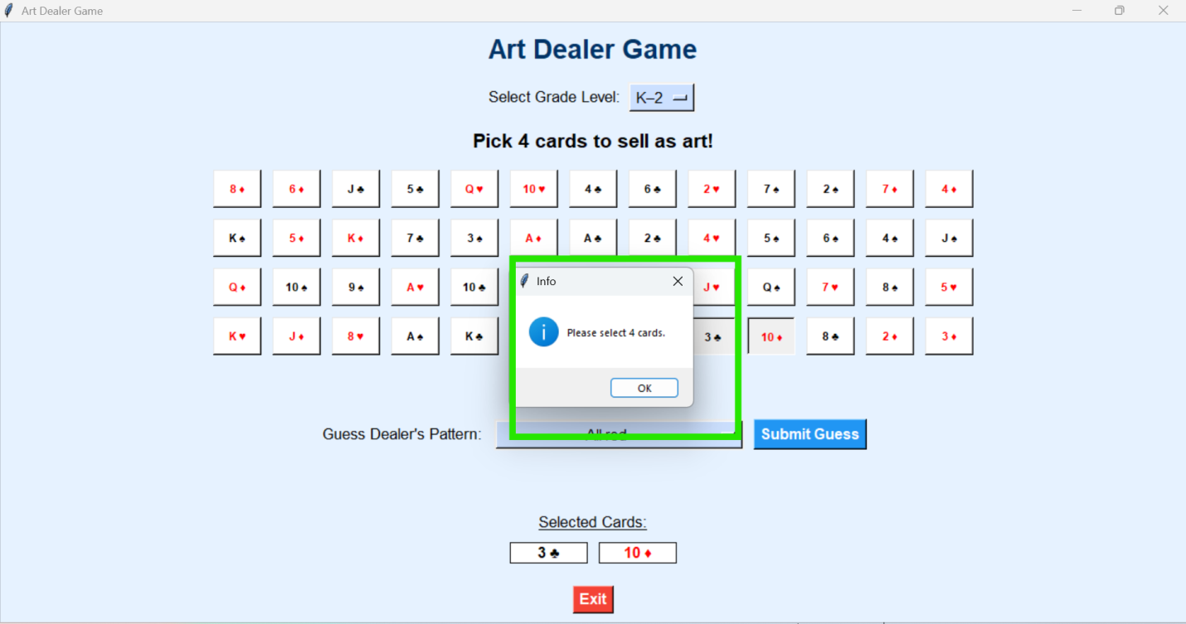

After selecting card you need to check with dealer by clicking on check with dealer button , after that you will be able to identify how many cards are picked by dealer, this use is shown in below figure

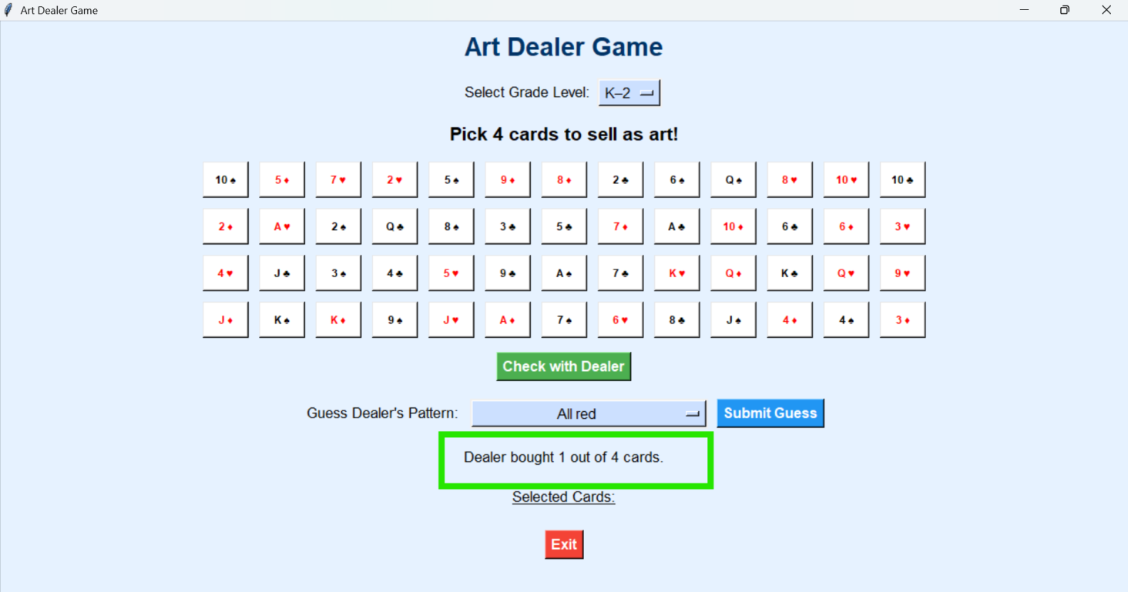

There are several guess patterns are present, for knowing the guesses list , you need to click on “Guess Dealers pattern” widget , then it will show the list shown in below figure

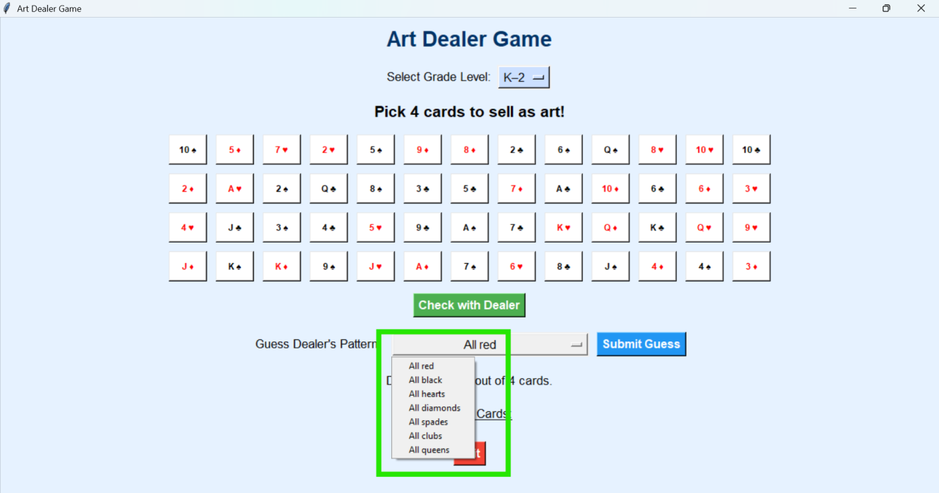

To know the guess is correct or not you need to click on submit guess button, there you can have three chances to identify the pattern, if the guess is wrong then a message will popup and said incorrect guess and how many chances left as shown in below figure

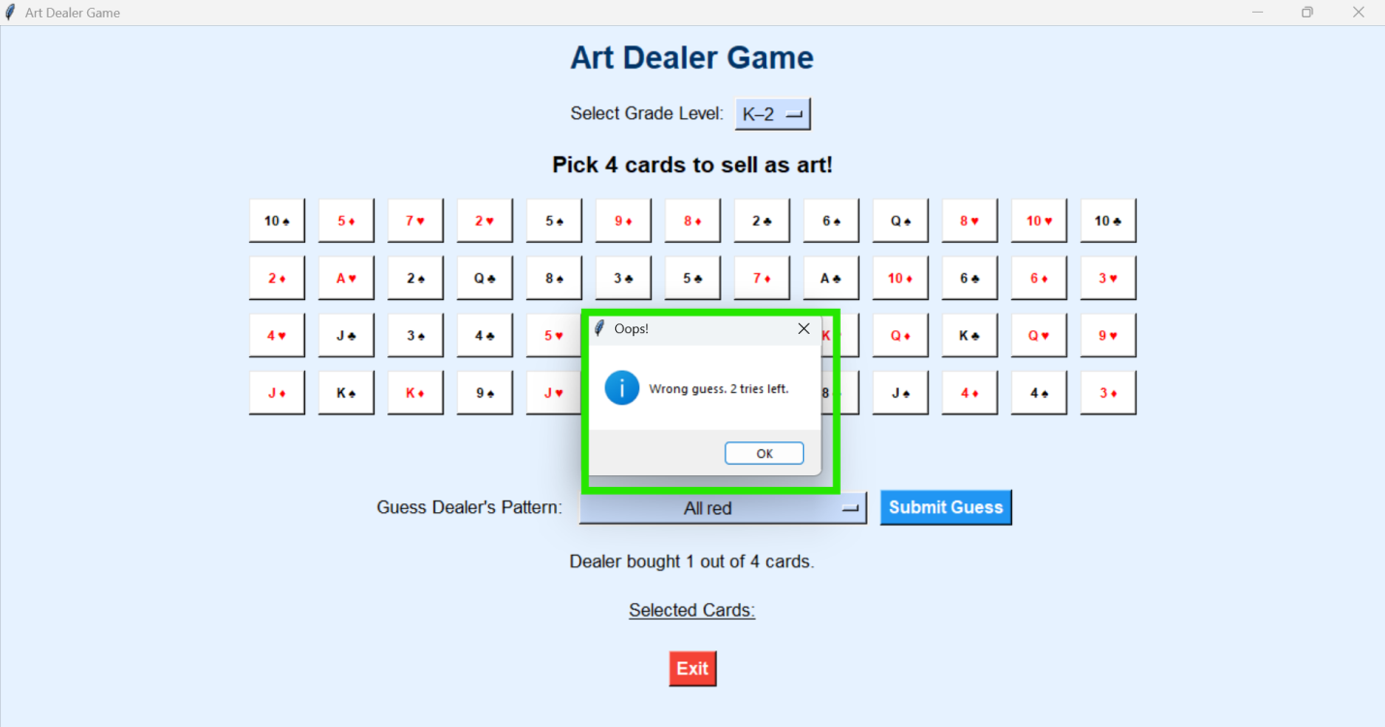

If you want to try another guess then you need to change the guess pattern , and try again for another guess. If your guess correct then a message will popup and said you win with a victory audio and ballons flying as shown below figure

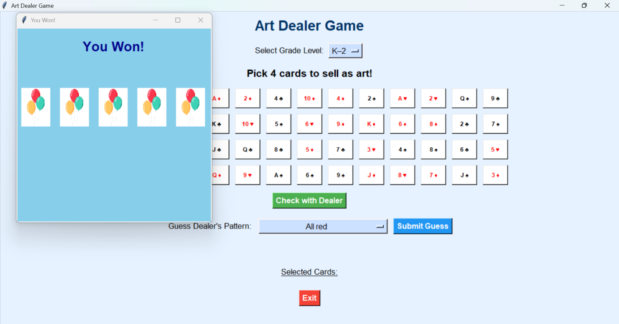

If you lost all of your attempts then a popup screen shows game over , and also message will popup with the dealers hidden guess shown below figures

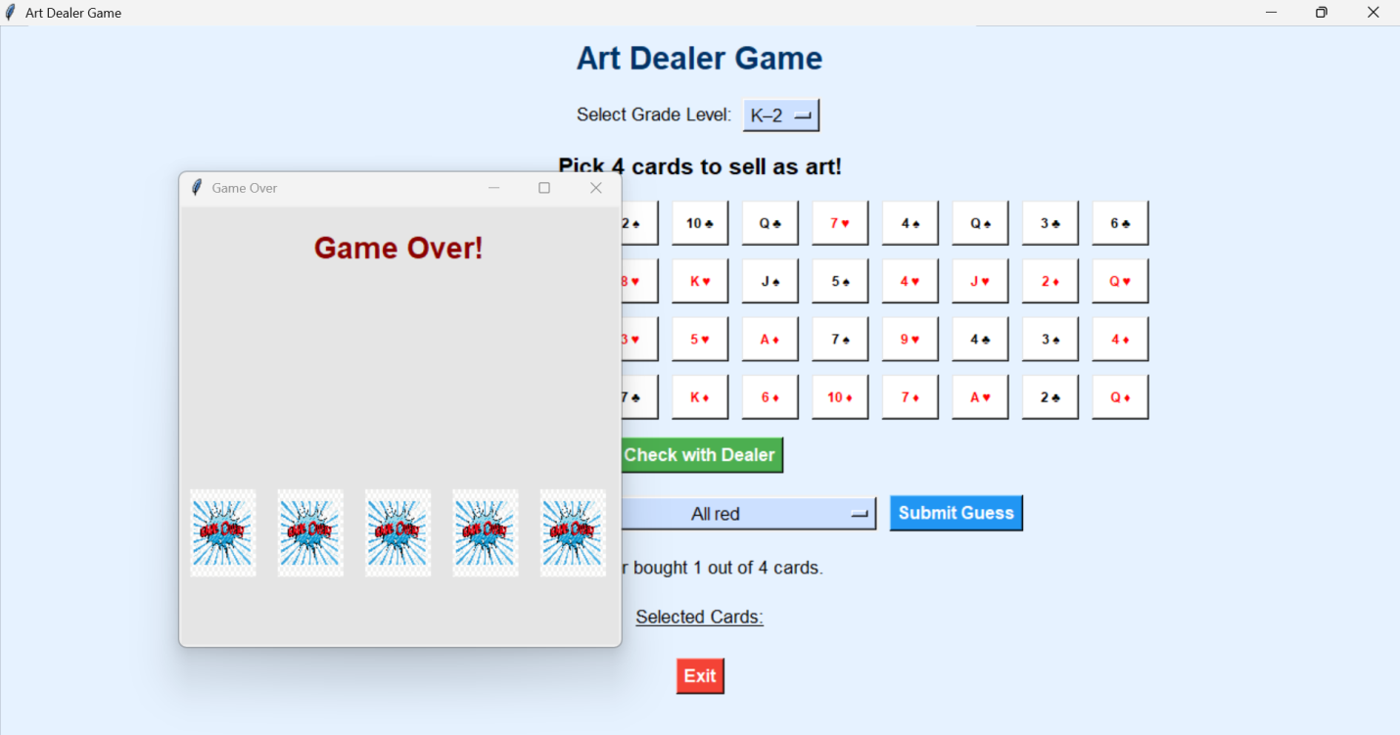

After that animation it will show the correct guess as message form shown in below figure

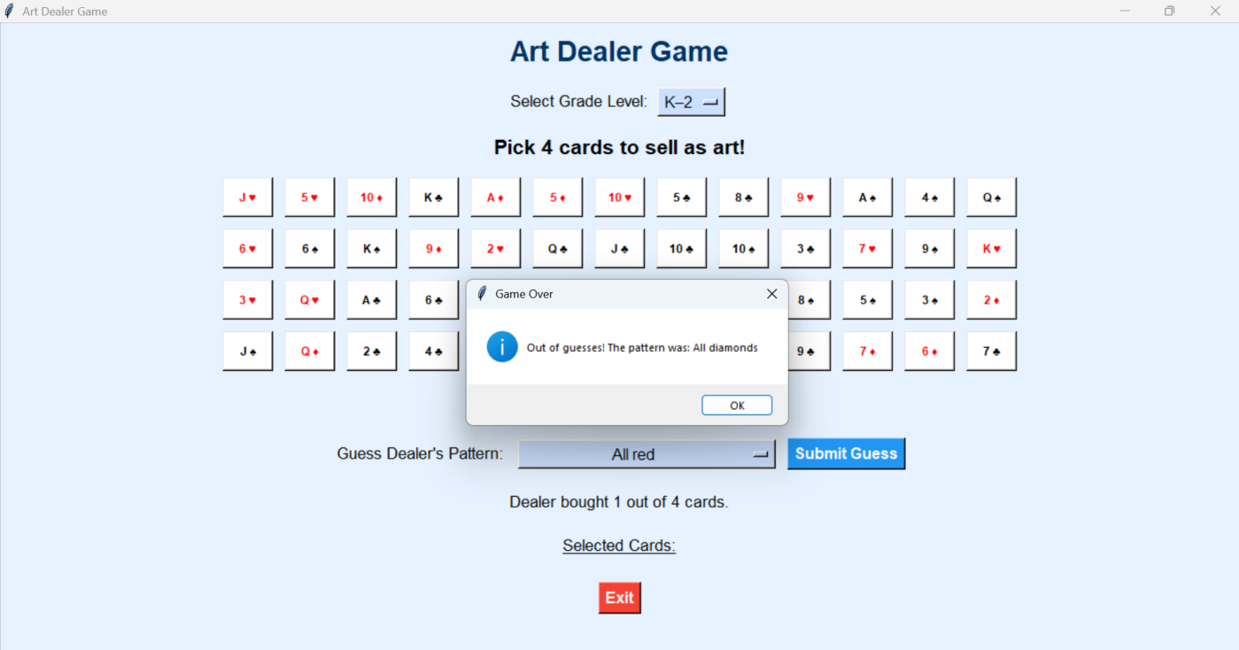

If you want to exit from this game then click on exit button on bottom of screen shown in below figure

